Performance of beams

A beam is a structural member designed to support various loading applied at points along the member. When a beam is loaded it will bend and this bendin is measured in newton millimetre or multiples of the units (e.g. kNm.).
The forces applied to a beam are counteracted by the supports which are called reactions (R_{L} left support and R_{R} right support)

Reaction types
Beams are usually supported on walls piers or columns which provide the necessary equilibrium. (According to Newton’s third law there is for every action an equal and opposite reaction.)
In simple terms the load on the beam is the action and the supports provide the reaction. There are three different support reaction:
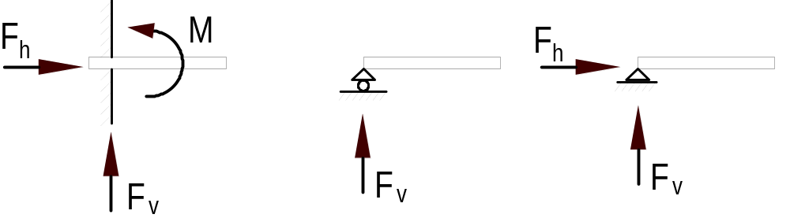
(a) fixed or build-in (b) roller bearing (c) pinned

Type (a) accommodate three reaction, (b) one reaction and type (c) two reaction.

Beam types
In this subject we will consider only simply supported beams which can be determinate completely with the three static equation. Continuous beams are beyond the scope of this subject. The two beam types are that we will use are shown below.

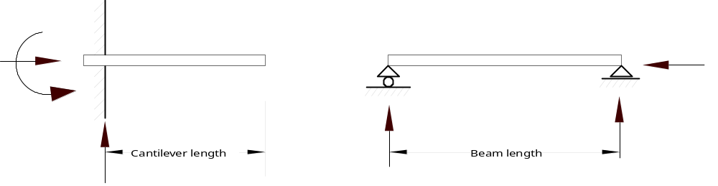 (a) Cantilever beam (b) Simply supported beam

Loading types
Beams are subjected to uniformly distributed loads (UDL), point (concentrated) loads or a combination of both. The various loading conditions to which a beam may be subjected to are shown below.
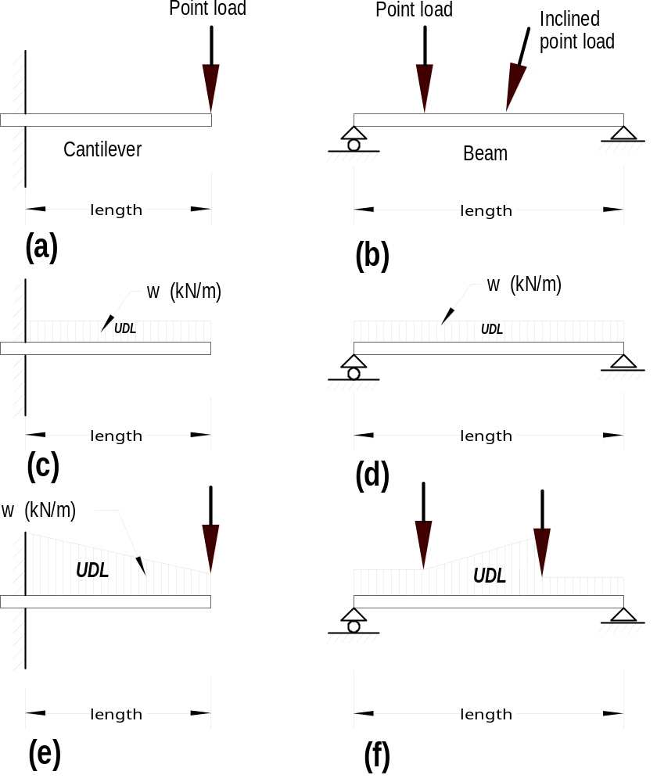
With the three static equation
Sum of the vertical forces must be zero Σ F_{v} = 0
Sum of the horizontal forces must be zero Σ F_{h} = 0

Sum of the moments forces must be zero Σ M = 0

simple structures (statically determinate) can be completely analysed.

To calculate the reaction of beams we use the equation Σ M = 0

The Shear force at any cross-section of the beam is equal to the algebraic sum of the external forces acting on one side of the section only

The Bending moment, at any point of the beam, is equal to the algebraic sum of the moments (taken about the point) of the external forces (loads & reactions) on one side of the section only.

Units

The unit of bending moment is the same as for moment of a force, i.e. the newton metre (Nm) and multiples and submultiples of this unit

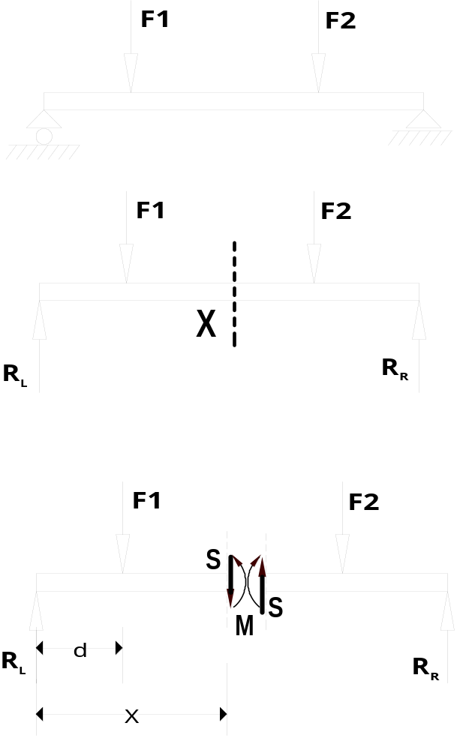1 We determine the reactions at the supports (R_{L} and R_{R}) by considering the whole system to be in a state of equilibrium.
Σ M R_{L} = 0 to determine R_{R}
Σ M R_{R} = 0 to determine R_{L}

- To determine the internal forces at point X cut the beam at this point into two section

- Redraw the two ‘parts’ of the beam; and draw the internal forces on the cut end of the beam portion to keep the system in balance

4 The bending moment is calculated by selecting the turning point at the cut edge. The BM for the left portion of the beam is:
BM = R_{l} × x – F1 × (x-d)

Sign convention for shear force and bending moment

The sign shear force (S) and bending moment (M) are positive (+) or negative (-) as shown below.


Internal forces at the section
(positive shear and positive bending)

Effect of external forces

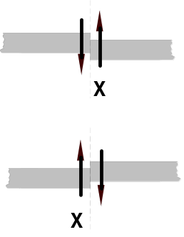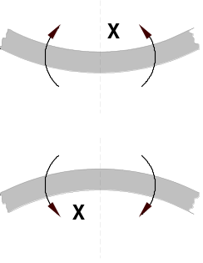 sagging
(positive shear) (= positive bending)

hogging
(negative shear) (= negative bending)

Determination of the reactions of a simple beam with a point load
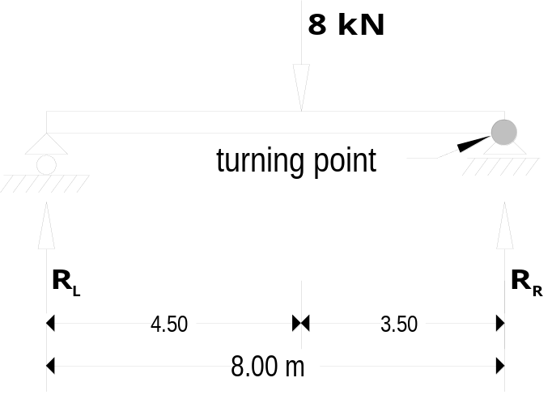Use the sum of the moments forces must be zero (Σ M = 0) equation to calculate the magnitude of the reactions

Clockwise moments positive, anti-clockwise moments negative.

Rotation about reaction R_{R}
Sum of the moments about R_{R} equals zero (Σ M R_{R} = 0)
R_{L} × 8.00 – 8 × 3.50 = 0
8R_{L} = 28.00
R_{L} = 3.50 kN
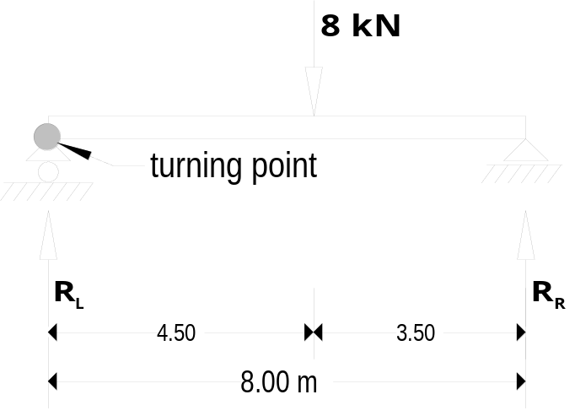To find R_{R} you could use the sum of the vertical forces must be zero. (Σ F_{V} = 0)

If this formula is used, it must be certain that R_{L} is correctly calculated. At this stage it is better to calculate R_{R}.
Sum of the moments about R_{L} equals zero. (Σ M R_{L} = 0)

-R_{R} × 8.00 + 8 × 4.50 = 0
8R_{R} = 36.00
R_{R} = 4.50 kN

Determination of the reactions of a simple beam with a uniformly distributed load
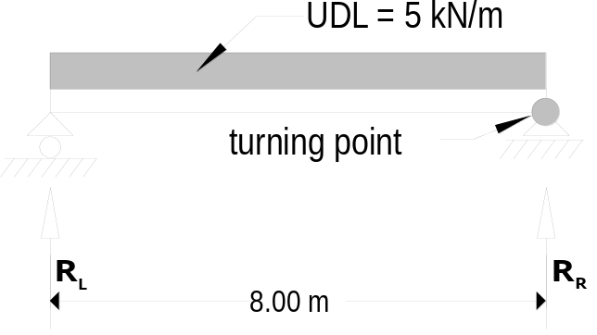
The principle to calculate the reaction is similar to the example above.
The uniformly distributed load can be substituted by a concentrated load acting in the centre of gravity of the UDL.

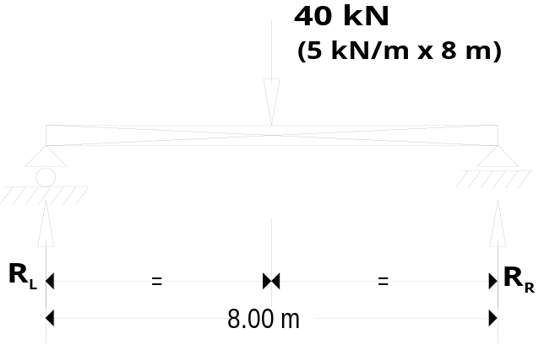The total load on beam is the UDL multiplied by the length of the beam,
i.e. 5 kN/m × 8.00 m = 40 kN. The centre of gravity of the UDL is at ½ of 8.00 m = 4.00 m

As symetrie exists there is no need to calculate the reaction. From inspection it can be seen that R_{L} = R_{R} = 40 kN/2 = 20 kN

Determination of the bending moment

A number of specifics loading cases occur frequently and for this cases standard formulas exist. The derivation of the bending moment formulas is dealt with in Structures 2

Standard formula for reactions, bending moments and deflections

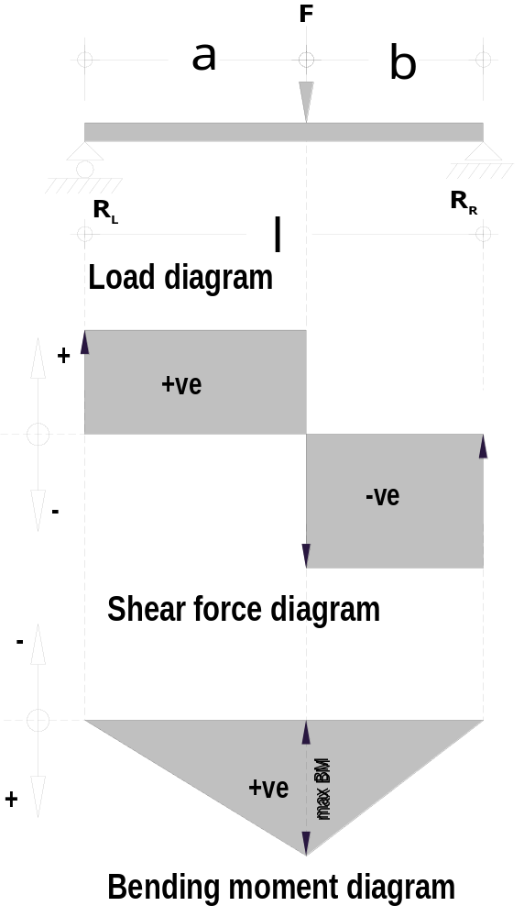
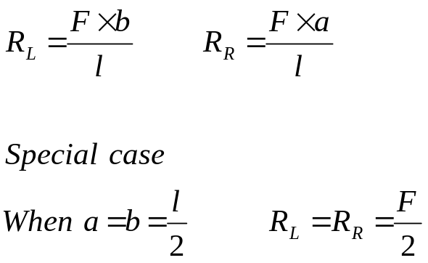Reactions:

Moments:
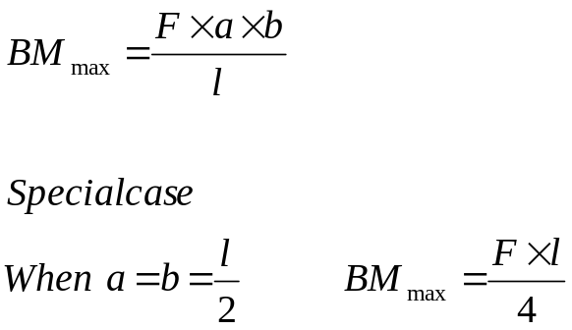
Deflection:
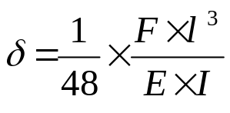The equation for this loading is too complex. The deflection formula for the special case (load in centre of beam) will be shown only

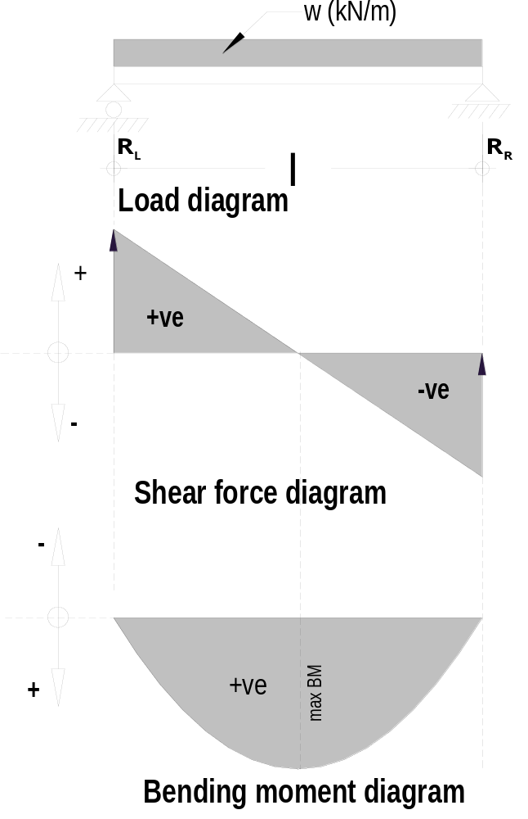Reactions:
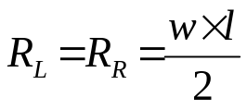
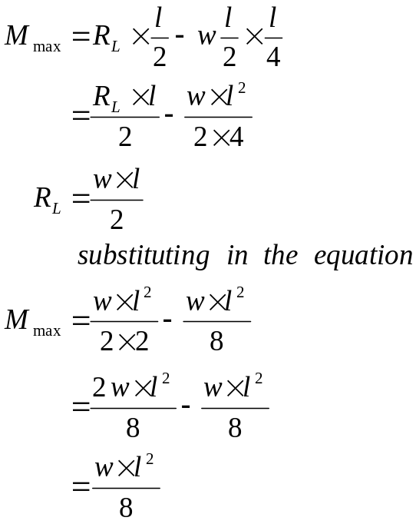
Moment:

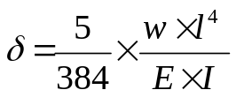Deflection:

For every load on a beam, there is a critical point at which a maximum bending moment occurs. The diagrams clearly indicate that this point is at zero shear. In other words where zero shear occurs there is the maximum bending moment.

Deflection
The factors that influence the deflection have been discussed previously. A constant factor that depends on the loading of the beam is introduced in the deflection equation above.
Note that w is load per metre, (in equation w × l⁴), if W = total load (w × l) then W × l³ must be used in the equation above.

